**ANNAMALAI  UNIVERSITY**

**DEPARTMENT OF ELECTRICAL ENGINEERING**

**ANNAMALAINAGAR**

**CHIDAMBARAM – 608002**

**B.E. (Electrical and Electronics Engineering)**

**Project Report**

**2022**

**VISION**

To develop the Department into a “Centre of Excellence” with a perspective to provide quality education and skill-based training with state of the art technologies to the students, thereby enabling them to become achievers and contributors to the industry, society and nation together with a sense of commitment to the profession.

**MISSION**

M1: To impart quality education in tune with emerging technological developments in the field of Electrical and Electronics Engineering.

M2: To provide practical hands-on-training with a view to understand the theoretical concepts and technological developments.

M3: To produce employable and self-employable graduates.

M4: To nurture the personality traits among the students in different dimensions emphasizing the ethical values and to address the diversified societal needs of our Nation

M5: To create futuristic ambiance with the state of the art facilities for pursuing research.

**A STUDY OF IOT BASED REAL-TIME SOLAR POWER REMOTE MONITORING SYSTEM**

**A Project Work**

***Submitted By***

|  |  |
| --- | --- |
| ANUSUYA.V | 181005007 |
| HARINIPRIYA.S | 181005027 |
| NISHA.R | 182005077 |
| VITHYASHRI.V | 161050230 |
| VINOTHINI.R | 181005085 |

**in partial fulfilment for the award of the Degree**

of

**BACHELOR OF ENGINEERING**

**IN**

**ELECTRICAL AND ELECTRONICS ENGINEERING**



**DEPARTMENT OF ELECTRICAL ENGINEERING**

**FACULTY OF ENGINEERING AND TECHNOLOGY**

**ANNAMALAI UNIVERSITY   
ANNAMALAINAGAR – 608 002**

**TAMIL NADU, INDIA**

**202****1-2022**

**ANNAMALAI UNIVERSITY**



**Department of Electrical Engineering**

**CERTIFICATE**

This is to certify that the project entitled ‘**A STUDY OF IoT BASED REAL-TIME SOLAR POWER REMOTE MONITORING SYSTEM’** submitted by **V.ANUSUYA** (181005007),**S.HARINIPRIYA** (181005027), **R.NISHA** (182005077), **V.VITHYASHRI** (161050230), **R.VINOTHINI** (181005085) to the Annamalai University for the award of the Degree of **Bachelor of Engineering in Electrical and Electronics Engineering** is a Bonafide work carried out by him/her under my supervision. The contents of this thesis, in full or in parts, have not been submitted to any other Institute or University for the award of any degree or diploma.

|  |  |  |  |  |
| --- | --- | --- | --- | --- |
| |  | | --- | | **Dr. R. NEELA** | | Supervisor | | Professor  Dept of Electrical Engineering  Annamalai University | |  |
| **Dr. S. SUBRAMANIAN**  Head of the Department |  |
| Dept of Electrical Engineering |  |
| Faculty of Engineering and Technology |  |
| Annamalai University |  |

|  |  |
| --- | --- |
| **Internal Examiner** | **External Examiner** |

ACKNOWLEDGEMENT

First of all, I thank the almighty for his blessings on me for doing my project successfully.

We would like to express our sincere thanks and deep sense of gratitude to

**Dr. S.SUBRAMANIAN**, Professor and Head, Department of Electrical Engineering, for his support and blessings for carrying out this project.

We are having immense pleasure and pride in offering wholehearted thanks to our project guide **Dr. R.NEELA**, M.E, Ph.D., Professor, Department of Electrical Engineering for her valuable guidance love and total support shown towards us for the successful completion of her project work.

We express our sincere thanks to **Dr. S. GANAPATHY**, M.E., Ph.D., Professor and Project coordinator, Department of Electrical Engineering, Annamalai University for his timely instruction and encouragement which has helped us to carry out the project successfully.

We thank all our friends for their valuable support and care shown towards us for the

successful completion of this project work.

**V.ANUSUYA**

**S.HARINIPRIYA**

**R.NISHA**

**V.VITHYASHRI**

**R.VINOTHINI**

ABSTRACT

We have developed an IoT-based real-time solar power monitoring system in this project. It seeks an open-source IoT solution that can collect real-time data and continuously monitor the power output and environmental conditions of a photovoltaic panel. The Objective of this work is to continuously monitor the status of various parameters associated with solar systems through sensors without visiting manually, saving time and ensures efficient power output from PV panels while monitoring for faulty solar panels, weather conditions and other such issues that affect solar effectiveness. Manually, the user must use a multimeter to determine what value of measurement of the system is appropriate for appliance consumers, which is difficult for the larger System. But the Solar Energy Monitoring system is designed to make it easier for users to use the solar system. This system is comprised of a microcontroller (Node MCU), a PV panel, sensors (INA219 Current Module, Digital Temperature Sensor, LDR), a Battery Charger Module, and a battery. The data from the PV panels and other appliances are sent to the cloud (Thingspeak) via the internet using IoT technology and a Wi-Fi module (NodeMCU). It also allows users in remote areas to monitor the parameters of the solar power plant using connected devices. The user can view the current, previous, and average parameters of the solar PV system, such as voltage, current, temperature, and light intensity using a Graphical User Interface. This will facilitate fault detection and maintenance of the solar power plant easier and saves time.

**திட்ட சுருக்கம்**

இந்தத் தாளில் IoTஅடிப்படையிலான நிகழ்நேர சூரிய சக்தி கண்காணிப்பு அமைப்பை நாங்கள் உருவாக்கியுள்ளோம். இது நிகழ்நேரத் தரவைச் சேகரிக்கும் மற்றும் ஒரு ஒளிமின்னழுத்த பேனலின் ஆற்றல் வெளியீடு மற்றும் சுற்றுச்சூழல் நிலைமைகளைத் தொடர்ந்து கண்காணிக்கக்கூடிய திறந்த மூல loTதீர்வைத் தேடுகிறது, இந்த வேலையின் நோக்கம் சூரிய மண்டலங்களுடன் தொடர்புடைய பல்வேறு அளவுருக்களின் நிலையை உணரிகள் மூலம் கைமுறையாகப் பார்வையிடாமல் தொடர்ந்து கண்காணிப்பதாகும். , நேரத்தைச் சேமிப்பது மற்றும் PV பேனல்களில் இருந்து திறமையான மின் உற்பத்தியை உறுதி செய்யும் போது தவறான சோலார் பேனல்கள், வானிலை மற்றும் சோலார் செயல்திறனைப் பாதிக்கும் பிற சிக்கல்களைக் கண்காணிக்கும் போது, ​​சாதன நுகர்வோருக்கு கணினியின் அளவீட்டின் மதிப்பு என்ன என்பதைத் தீர்மானிக்க பயனர் மல்டிமீட்டரைப் பயன்படுத்த வேண்டும். இது பெரிய அமைப்பிற்கு கடினமானது. ஆனால் சோலார் எனர்ஜிமானிட்டரிங் சிஸ்டம் பயனர்கள் சோலார் சிஸ்டத்தைப் பயன்படுத்துவதை எளிதாக்கும் வகையில் வடிவமைக்கப்பட்டுள்ளது. இந்த அமைப்பானது மைக்ரோகண்ட்ரோலர் (NodeMCU), ஒரு PV பேனல், சென்சார்கள் (INA219 மின்னோட்டம்சென்சார், டிஜிட்டல் வெப்பநிலை சென்சார், LDR), ஒரு பேட்டரி சார்ஜர் தொகுதி மற்றும் ஒரு பேட்டரி ஆகியவற்றைக் கொண்டுள்ளது. PV பேனல்கள் மற்றும் பிற சாதனங்களில் இருந்து தரவுகள் (data) இணையம் வழியாக கிளவுட் திங்ஸ்பீக் (thingspeak) க்கு loT தொழில்நுட்பம் மற்றும் Wi-Fi தொகுதி (NodeMCU) மூலம் அனுப்பப்படும். தொலைதூரப் பகுதிகளில் உள்ள பயனர்கள் இணைக்கப்பட்ட சாதனங்களைப் பயன்படுத்தி சூரிய மின் நிலையத்தின் அளவுருக்களைக் கண்காணிக்கவும் இது அனுமதிக்கிறது. சூரிய PV அமைப்பின் தற்போதைய, முந்தைய மற்றும் சராசரி அளவுருக்களான மின்னழுத்தம், மின்னோட்டம், வெப்பநிலை மற்றும் ஒளி தீவிரம் போன்றவற்றை வரைகலை பயனர் இடைமுகத்தைப் பயன்படுத்தி பயனர் பார்க்கலாம். இது சூரிய மின் நிலையத்தின் தவறுகளைக் கண்டறிந்து பராமரிப்பதை எளிதாக்குவதோடு நேரத்தையும் மிச்சப்படுத்தும்.

TABLE OF CONTENTS

|  |  |  |  |  |  |  |
| --- | --- | --- | --- | --- | --- | --- |
| **CHAPTER NO.** | | **TITLE** | | | **PAGE NO.** | |
|  | | **ACKNOWLEDGEMENT** | | | **I** | |
|  | | **ABSTRACT** | | | **II** | |
|  | | **திட்டசுருக்கம்** | | | **III** | |
|  | | **LIST OF FIGURES** | | | **IV** | |
|  | | **LIST OF TABLES** | | | **V** | |
|  | | **NOMENCLATURE** | | | **VI** | |
| **1** | **INTRODUCTION** | | | | | **1** |
|  | |  | | |  | |
|  | | 1.1 | General | | **1** | |
|  | | 1.2 | Literature Survey / Existing Systems | | 2 | |
|  | | 1.3 | Objectives of the Project | | 3 | |
|  | | 1.4 | Organization of the Report | | 4 | |
| **2** | | **PROPOSED METHODOLOGY** | | | **5** | |
|  | | 2.1 | General | | 6 | |
| **3** | | **INTERNET OF THINGS** | | | **7** | |
|  | | 3.1 | Introduction | | 7 | |
|  | | 3.2 | Importance of Internet of Things | |  | |
|  | | 3.3 | Working of Internet of Things | |  | |
|  | | 3.4 | Benefits of Internet of Things | | 10 | |
| **4** | | **SOLAR ENERGY** | | |  | |
|  | | 4.1 | General | |  | |
|  | | 4.2 | Solar cells | |  | |
|  | | 4.3 | Types of solar PV cells | |  | |
|  | | 4.4 | Solar PV modules | |  | |
|  | | 4.5 | Applications of Solar PV modules | |  | |
| **5** | | **THINGSPEAK** | | |  | |
|  | | 5.1 | General | |  | |
|  | | 5.2 | Key Features | |  | |
|  | | 5.3 | Works with | |  | |
| **6** | | **ESP8266 WIFI** **MODULE** | | |  | |
|  | | 6.1 | Introduction | |  | |
|  | | 6.2 | Pin Configuration | |  | |
|  | | 6.3 | Module specification | |  | |
|  | | 6.4 | Applications of wifi module | |  | |
|  | | 6.5 | Circuit diagram and Working | |  | |
|  | | 6.6 | Node MCU | |  | |
|  | | 6.7 | Features and Specifications | |  | |
|  | | 6.8 | Pin board Configuration | |  | |
|  | | 6.9 | Applications | |  | |
| **7** | | **SENSORS**  7.1 |  | |  | |
| Introduction | |  | |
|  | | 7.2 | Light Dependant Resistor (LDR) | |  | |
|  | | 7.3 | INA219 Current sensor | |  | |
|  | | 7.4 | DS18B20 Temperature sensor | |  | |
| **8** | | **BATTERY AND CHARGER MODULE** | | |  | |
|  | | 8.1 | | Introduction |  | |
|  | | 8.2 | | Battery Charger Module |  | |
| **9** | | **HARDWARE SETUP** | | |  | |
| **10** | | **RESULTS AND DISCUSSION** | | |  | |
| **11** | | **CONCLUSION** | | |  | |
| **12** | | **REFFERENCES** | | |  | |
| **13** | | **APPENDIX** | | |  | |

LIST OF FIGURES

|  |  |  |  |
| --- | --- | --- | --- |
| **FIGURE. NO.** | | **TITLE** | **PAGE NO.** |
| 1 | | Proposed model of the IoT based solar power monitoring system | 7 |
| 2 | | Flow chart of the Proposed system | 1 |
| 6 | | Pin configuration of ESP8266 module | 20 |
| 7 | | Circuit diagram of ESP8266 | 22 |
| 12 | | Schematic diagram of INA219 current sensor | 25 |
| 14 | | Circuit diagram of DS18B29 temperature sensor | 37 |
| 15 | Experimental setup of proposed system | | 46 |
| 16 | Practical circuit diagram of proposed system | | 47 |

LIST OF TABLES

|  |  |  |
| --- | --- | --- |
| **TABLE NO.** | **TITLE** | **PAGE NO.** |
| 1 | Pin board configuration of NodeMCU | 26 |
| 2 | Pin description of INA219 current sensor | 33 |
| 3 | Summary of registers in INA219 current sensor | 33 |
| 4 | Pin configuration of DS18B20 temperature sensor | 39 |

NOMENCLATURE

|  |  |
| --- | --- |
| **ABBREVIATIONS** | |
| TCP | Telecommunication Control Protocol |
| IP | Internet Protocol |
| GPIO | General Purpose Input / Output |
| PCB | Printed Circuit Breakers |
| I2C | Inter-Integrated Circuit |
| MCU | Microcontroller Unit |
| WiFi | Wireless Fidelity |
|  | **GREEK SYMBOLS** |
| **μ** | Permeability factor |
| **Ω** | Electrical resistance |
|  | |
|  |

# CHAPTER 1

# INTRODUCTION

**1.1 GENERAL**

The Internet of Things (IoT) is a technological advancement that connects computing devices, machines, and objects in everyday life with special identifiers and data transfer over a network without requiring human-to-human or human-to-PC communication. This technology facilitates data exchange between connected devices on a network. The internet enables users to access data and control devices from anywhere in the world.

Power generation is a major factor in many developing countries. Due to the improvement of the industrial and commercial sector, energy demand reaches its peak. Hence all are poignant towards renewable energy source to produce green energy for meeting out our energy consumption. This can help the society to decrease greenhouse gas emission and ozone layer depletion for future generation. Among this solar photovoltaic technique is gaining popularity due to huge availability, reduced cost, easy installation, and maintenance.

Currently, Internet of Things (IoT) is an evolving technology that makes things smarter and user-friendly when connected through the communication protocol and cloud platform. The efficiency of the solar panel is influenced by basic parameters such as current, voltage, Irradiance, and temperature. Hence real-time solar monitoring system is essential for increasing the performance of the PV panel by comparing with the experimental result to initiate preventive action. In recent years there had been a lot of research attempts made in solar energy.

The main goal of the Solar Power Monitoring System is to promote a data acquisition system that continuously appears remote energy yields. Electricity is required in today's world for heating, lighting, refrigeration, transportation systems, and all home appliances. The graph of energy consumption is increasing day by day, while the graph of energy resources is decreasing.

So, in order to balance the electricity deficit, we are using renewable sources such as the sun, wind energy, and tidal energy to generate electricity that can be reused instead of non-renewable sources such as coal, natural gas, and fossil fuels, which are depleting on a daily basis. That is why solar power is referred to as an indestructible energy source.

The Measured parameters are evaluated with the standard operating condition to provide necessary action for better performance of PV. A low-cost solar panel monitoring is developed based on IoT for online visualization and improving the performance. This helps to take preventive maintenance and tracking the fault location.

As a result, an IoT-based solar power monitoring system is being proposed to address the issues associated with electricity scarcity.In general, our country experiences relatively sunny days for approximately 7 to 9 months of the year, with partially cloudy skies the remainder of the time. This makes our country, especially the areas of Teknaf, Sutiakhali, Mymensingh, and Sunamganj, Cox-bazar prosperous in terms of solar power harnessing. Solar power plants must be monitored to ensure that they are producing the maximum amount of power.Because the range of the sun's radiation is not fixed and can vary depending on location, time, and climatic conditions, solar panels that are exposed to the sun must always be monitored.

The proposed system is an IoT-based solar power monitoring system. Solar cells, which are found in solar panels, convert sunlight into electricity in this system. We use a Node MCU Wi-Fi module, and sensors to measure current-voltage parameters, power, temperature, and light intensity. An IoT device is also linked to the sensors, allowing the displayed parameter to be monitored from any location using any available network.

### 1.2 LITERATURE REVIEW

A smart monitoring system is created that used a microcontroller and Lab view to maximize efficiency with the use of sun trackers[1]. The Internet of Things is being used to develop a low-cost solar panel monitoring system for web-based visualization and improved performance. This helps with maintenance and tracking the location of faults[2].

The Raspberry Pi is used to propose and develop an IoT-based cloud monitoring system for remote PV plants[3]. A low-cost smart architecture is proposed to optimize PV panel efficiency by detecting performance degradation via a continuous monitoring system[4]. A real-time supervising and data collection model for solar PV modules are developed using LABVIEW to determine the performance of various solar PV ratings[5-6]. A PV monitoring system is designed to send parameters via wired and wireless networks to a remote coordinator, who then provides a web-based application for remote access[7].

A simple forecasting database is modeled without using existing automation tools, utilizing MySQL to collect raw data, filter out irrelevant values, and generate forecasts. In order to achieve robust performance, machine intelligence techniques are also used for forecasting[8]. A remote solar monitoring and control system for plant operation is proposed, which facilitates decision-making for the central control station, which plays a crucial role in processing, storage, warning, and displaying[9]. To study fault diagnosis in PV plants, the basic characteristics of a PV system are researched using the LABVIEW tool for real-time measurement[10].

Lab View is being used to create a usable graphical user interface for the online monitoring of solar photovoltaic systems. The Arduino controller explores the measured parameters and sends the data to the server to make an effective decision that improves the PV panel's effectiveness[11].

A microcontroller-based displaying system is proposed to monitor the various factors influencing the performance of PV panels. In order to provide the necessary action for improved PV performance, the measured parameters are compared with the standard operating conditions [12]. A smart controller based on the HEM algorithm is used to select the source priority in order to maximize the use of Solar PV for home power management [13].

As a result, the proposed work demonstrates a real-time Solar PV monitoring system using a cost-effective Smart Controller that communicates with a cloud platform that provides large storage space as well as fast data access.

### 1.3 EXISTING SYSTEM

The solar panels are monitored using a controller and current and voltage are sensed using current and potential transformers.

The solar tracking is not implemented and controlling of solar panel is not done till now.

Therefore the solar panel is not used to its maximum potential at each instant of time.

### 1.4 OBJECTIVE OF THE WORK

The Objective of this work is to continuously monitor the status of various parameters associated with solar systems through sensors without visiting manually, saving time and ensures efficient power output from PV panels while monitoring for faulty solar panels, weather conditions and other such issues that affect solar effectiveness. Manually, the user must use a multimeter to determine what value of measurement of the system is appropriate for appliance consumers, which is difficult for the larger System. But the Solar Energy Monitoring system is designed to make it easier for users to use the solar system. This will facilitate fault detection and maintenance of the solar power plant easier and saves time.

### 1.5 ORGANIZATION OF THE REPORT

**CHAPTER 1**

In this chapter, a brief introduction to Internet of things (Iot)

**CHAPTER 2**

Proposed methodology of this project is discussed.

**CHAPTER 3**

Chapter 3 describes IoT and its application in various fields.

**CHAPTER 4**

Chapter 4 deals with the solar panel. The principle of operation of the solar panel is presented.

**CHAPTER 5**

Chapter 5 describes about Thinkspeak cloud platform

**CHAPTER 6**

This chapter finely describes about the WiFi module used in this project.

**CHAPTER 7**

This chapter clearly describes about the sensors which has been used.

**CHAPTER 8**

This chapter finely describes battery and battery charger module.

**CHAPTER 9**

Chapter 9 describes the development of hardware and their description of the

proposed system.

**CHAPTER 10**

This chapter deals with discussion of the results

**CHAPTER 11**

Concluding the proposed work.

**1.6 SUMMARY**

In this chapter, a brief introduction a to PV system, a literature review is done on smart monitoring system for PV system and the system and the objective of this

project is also presented.

**CHAPTER 2**  
**PROPOSED METHODOLOGY**

**2.1 GENERAL**

Figure 1 depicts the proposed model of this system, which shows the interconnection of these blocks. This System uses a Node MCU microcontroller having ESP8266 Wi-Fi module which control all the data associated with the PV panel. Here voltage and current sensor module senses the voltage, current and power developed on PV panel which are read by Node MCU. The environment temperature and the amount of Light intensity falling on PV are measured by Temperature Sensor and LDR respectively. The sensors which are linked to the microcontroller (Node MCU) are powered by a power supply. The Node MCU serves as the foundation for live streaming current, voltage, power, light intensity, and temperature, as well as sending sensor data to the server via the ESP8266 Wi-Fi module. Extra power will be stored in the battery via the Battery Charger Module for later use. As a result, the user can keep an eye on the aforementioned parameter.



### Figure 1. Proposed model of the IoT-based solar power monitoring system

The proposed system's flowchart is showed in Figure 2. When a connection is established between the NodeMCU and the Thingspeak server, the NodeMCU sends various sensor data to the Thingspeak server's various fields. The user can then monitor sensor data from any location through the internet.

### 

### Figure 2. Flowchart of the proposed system

# CHAPTER 3 INTERNET OF THINGS

# 3.1 INTRODUCTION

IoT stands for Internet of Things, which means accessing and collecting daily usable equipments and devices using internet. The term “things” in the internet of things refers to anything and everything in day to day life which is accessed or connected through the internet. IoT is an advanced automation and analytics system which deals with artificial intelligence, sensor, networking, electronic, cloud messaging etc. To deliver complete systems for the product or services. The system created by IoT has greater transprancy, control, and performance.

As we have a platform such as cloud that contains all the data through which we connect all the things around as.

The working of IoT is different for different IoT echo system (architecture). However, the key concept of there working are similar. The entire working is similar. The entire working process of IoT starts with the device themselves, such as smart phones, digital watches, electronic appliances, which securely communicate with the IoT platform. The platforms collect and analyse the data from all multiple devices and platforms and transfer the most valuable data with applications to devices.

**3.2 IMPORTANCE OF INTERNET OF THINGS (IoT)**

Over the past few years, IoT has become one of the most important technologies of the 21st century. Now that we can connect everyday objects kitchen appliances, cars, thermostats, baby monitors to the internet via embedded devices, seamless communication is possible between people, processes, and things.

By means of low-cost computing, the cloud, big data, analytics, and mobile technologies, physical things can share and collect data with minimal human intervention. In this hyper connected world, digital systems can record, monitor, and adjust each interaction between connected things. The physical world meets the digital world and they cooperate.

## 3.3 WORKING OF IoT

An IoT ecosystem consists of web-enabled smart devices that use embedded systems, such as processors, sensors and communication hardware, to collect, send and act on data they acquire from their environments. [IoT devices](https://internetofthingsagenda.techtarget.com/definition/IoT-device) share the sensor data they collect by connecting to an IoT gateway or other edge device where data is either sent to the cloud to be analyzed or analyzed locally. Sometimes, these devices communicate with other related devices and act on the information they get from one another. The devices do most of the work without human intervention, although people can interact with the devices for instance, to set them up, give them instructions or access the data.

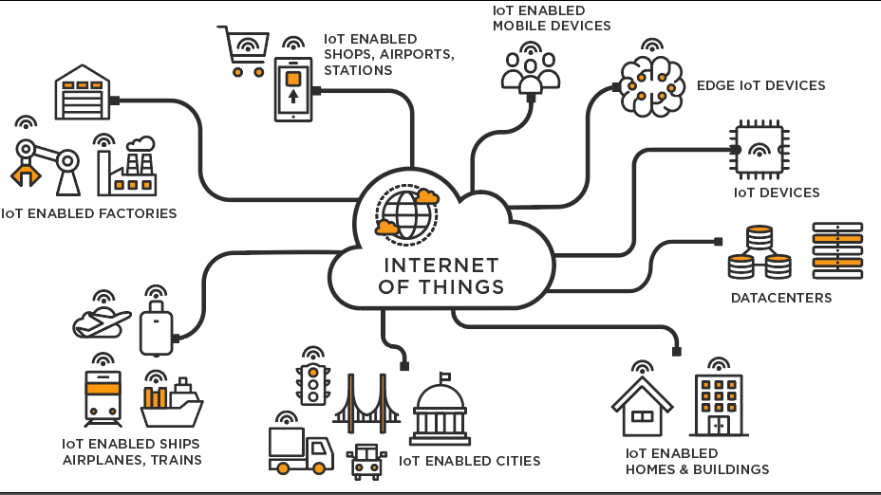

**Figure 3. Internet of Things and applications**

**3.4 BENEFITS OF INTERNET OF THINGS**

The internet of things offers several benefits to organizations. Some benefits are industry-specific, and some are applicable across multiple industries. Some of the common benefits of IoT enable businesses to:

1) Monitor their overall business processes  
 2) Improve the customer experience (CX)  
 3) Save time and money  
 4) Enhance employee productivity  
 5) Integrate and adapt business models  
 6) Make better business decisions  
 7) Generate more revenue.

IoT encourages companies to rethink the ways they approach their businesses and gives them the tools to improve their business strategies.

Generally, IoT is most abundant in manufacturing, transportation and utility organizations, making use of sensors and other IoT devices; however, it has also found use cases for organizations within the agriculture, infrastructure and home automation industries, leading some organizations toward digital transformation.

IoT can benefit farmers in agriculture by making their job easier. Sensors can collect data on rainfall, humidity, temperature and soil content, as well as other factors, that would help automate farming techniques.

The ability to monitor operations surrounding infrastructure is also a factor that IoT can help with. Sensors, for example, could be used to monitor events or changes within structural buildings, bridges and other infrastructure. This brings benefits with it, such as cost saving, saved time, quality-of-life workflow changes and paperless workflow.  
  
A home automation business can utilize IoT to monitor and manipulate mechanical and electrical systems in a building. On a broader scale, smart cities can help citizens reduce waste and energy consumption. IoT touches every industry, including businesses within healthcare, finance, retail and manufacturing

**CHAPTER 4  
SOLAR ENERGY**

**4.1 GENERAL**

Solar energy is radiant light and heat from the sun, and can be harnessed using a range of technologies such as solar heating, solar photovoltaic and solar thermal electricity. Solar energy is a renewable source of energy that is sustainable and totally inexhaustible, unlike fossil fuels that are finite. It is considered an environmentally friendly source of energy because it comes directly from the sun, it does not involve any burning of fuel. Solar energy has been one of the fastest-growing sources of new energy in the world for many years now.

**4.2 SOLAR CELLS**

The Sun's light energy can be converted directly into electricity in a single process using Photovoltaic (PV) cells, otherwise known as solar cells. A PV cell is a thin plate of light sensitive material made primarily of silicon, the second most abundant element in the earth 's crust, and the same semiconductor material used for computers. When the silicon is combined with one or more other materials, it exhibits unique electrical properties in the presence of sunlight. Electrons are agitated by the light and move through the silicon. This is known as the photovoltaic effect and results in direct current (DC) electricity.  
  
Many PV cells are linked together to create a standard PV module, which in turn are linked together into a PV array. PV modules have no moving parts, are virtually maintenance-free although they should be kept clean and clear of shading, and have a working life of [20-30](tel:20-30) years. The PV array produces direct current (DC) electricity. An "inverter" is used to convert the DC to alternating current (AC), so the power is the same as normal grid power and can be used in household appliances. The inverter is a box of electronics, like a computer.

**4.3 TYPES OF SOLAR PV CELLS**

1. Mono-crystalline Solar Modules
2. Polycrystalline Solar Modules
3. Thin-film Solar Modules
   1. **SOLAR PV MODULE**

Solar PV modules are made by connecting together photovoltaic (PV) cells or solarcells. They are manufactured from semiconductor materials like crystalline silicon. Solar modules convert the light energy captured from the sun into electric energy. The electric energy so produced is used for lighting residential and commercial establishments.

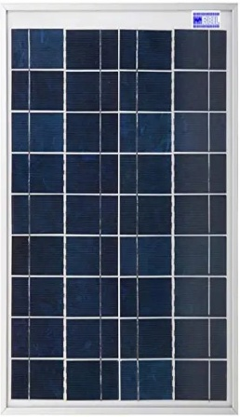

**Figure 4. Solar PV Panel**

* 1. **APPLICATIONS OF SOLAR PV MODULE**

When a number of modules are connected to the grid PV system via an inverter, they

transform DC current generated by the solar PV modules to AC current. The electricity

generated can be used for lighting purposes and powering household appliances. The excess

electricity can be sold to the grid directly. Individual solar PV modules can be used for powering torches, flashlights, wrist watches, etc. In remote and rural locations.

**4.6 SUMMARY**

The solar panel considered in the project has rating of 5W, 12V respectively.

# CHAPTER 5 THINK SPEAK

**5.1 GENERAL**

ThingSpeak is an IoT analytics platform service that allows you to aggregate, visualize and

Analyze live data streams in the cloud. ThingSpeak provides instant visualizations of data

posted by your devices to ThingSpeak. With the ability to execute MATLAB code in

ThingSpeak you can perform online analysis and processing of the data as it comes in.

ThingSpeak is often used for prototyping and proof of concept IoT systems that require analytics.

**5.2 KEY FEATURES**

ThingSpeak allows you to aggregate, visualize and analyze live data streams in the cloud.

Some of the key capabilities of ThingSpeak include the ability to:

1. Easily configure devices to send data to ThingSpeak using popular IoT protocols.
2. Visualize your sensor data in real-time.
3. Aggregate data on-demand from third-party sources.
4. Use the power of MATLAB to make sense of your IoT data.
5. Run your IoT analytics automatically based on schedules or events.
6. Prototype and build IoT systems without setting up servers or developing web software.
7. Automatically act on your data and communicate using third-party services like Twitter.

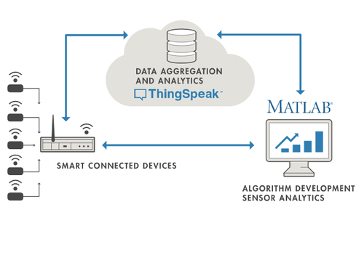

**Figure 5. Thingspeak working**

**5.3 WORKS WITH**

1. MATLAB &Simulink
2. Arduino
3. Particle devices
4. ESP8266 and ESP32Wifi-Modules
5. RaspberryPi
6. LoRaWAN
7. ThingsNetwork
8. Senet
9. Libelium
10. Beckhof

**CHAPTER 6**

**ESP8266 WIFI MODULE AND CONTROLER**

**6.1 GENERAL**

The ESP8266 WiFi Module is a self contained SOC with integrated TCP/IP protocol stack that can give any microcontroller access to your WiFi network. The ESP8266 is capable of either hosting an application or off loading all WiFi networking functions from another application processor. Each ESP8266 module comes pre programmed with an AT command set firmware, meaning, you can simply hook this upto your Arduino device and get about as much WiFi-ability as a WiFi Shield offers.

The ESP8266 module is an extremely cost effective board with a huge, and ever growing, community. This module has a powerful enough on-board processing and storage capability that allows it to be integrated with the sensors and other application specific devices through its GPIOs with minimal development up front and minimal loading during runtime.

Its high degree of on-chip integration allows for minimal external circuitry, including the front-end module, is designed to occupy minimal PCB area. The ESP8266 supports APSD for VoIP applications and Bluetooth co-existance interfaces, it contains a self-calibrated RF allowing it to work under all operating conditions, and requires no external RF parts.

**6.2 PIN CONFIGURATION / PIN DIAGARM**

The ESP8266 Wi-Fi module pin configuration/ pin diagram is shown in the figure below. The

ESP8266-01Wi-Fi module runs in two modes. They are

1. **Flash Mode:** When GPIO-0 and GPIO-1 pins are active high, then the module runs the program, which is uploaded into it.
2. **UART Mode:** When the GPIO-0 is active low and GPIO-1 is active high, then the module works in programming mode with the help of either serial communication or Arduino board.

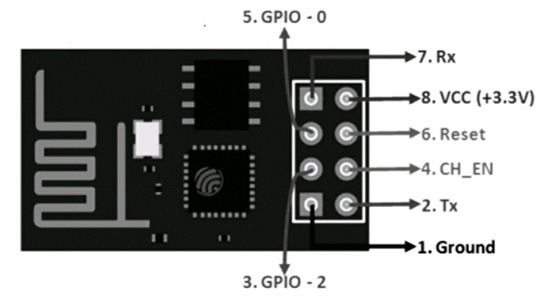

**Figure 6. Pin configuration of ESP2688 WiFi module**

**6.3 MODULE SPECIFICATIONS**

The ESP8266 Wi-Fi module specifications or features are given below.

1. It is a powerful Wi-Fi module available in a compact size at a very low price.
2. It is based on the L106RISC 32-bit microprocessor core and runs at 80MHz
3. It requires only 3.3Volts power supply
4. The current consumption is 100m Amps
5. The maximum Input/Output (I/O)voltage is 3.6Volts.
6. It consumes 100mA current
7. The maximum Input/Output source current is 12mA
8. The frequency of built-in low power 32-bit MCU is 80MHz
9. The size of flash memory is 513kb
10. It is used as either an access point or station or both
11. It supports less than 10 micro Amps deep sleep
12. It supports serial communication to be compatible with several developmental platforms such as Arduino
13. It is programmed using either AT commands, Arduino IDE,or Lua script
14. It is a 2.4GHz WiFi module and supports WPA/WPA2,WEP authentication, and open networks.
15. It uses two serial communication protocols like I2C (Inter-Integrated Circuit) and SPI(Serial Peripheral Interface).
16. It provides 10-bit analog to digital conversion The type of modulation is PWM(Pulse Width Modulation)
17. UART is enabled on dedicated pins and for only transmission, it can be enabled on GPIO2.
18. It is an IEEE802.11 b/g/n Wi-Fi module with LNA, power amplifier, balun, integrated TR switch, and matching networks.
19. GPIO pins–17
20. Memory Size of instruction RAM–32KB
21. The memory size of instruction cache RAM–32KB
22. Size of User-data RAM-80KB
23. Size of ETS systems-data RAM–16KB

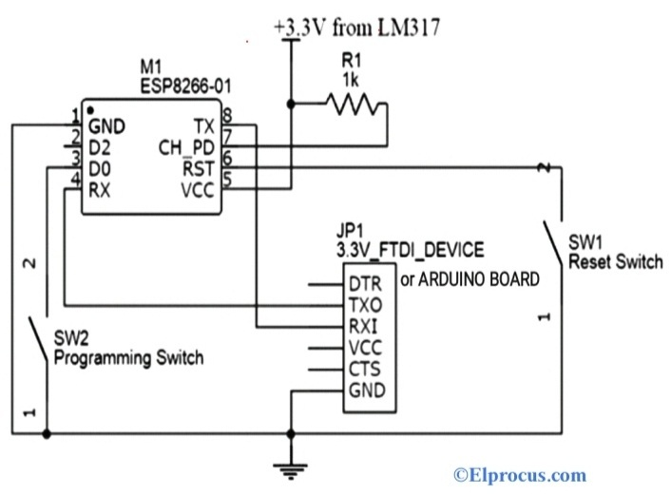

**Figure 7. circuit diagram of ESP8266 module**

**6.4 APPLICATIONS OF WIFI MODULE**

The applications of the ESP8266 Wi-Fi module are given below

1. Access points portals
2. IoT projects
3. Wireless data logging
4. Used in learning the networking fundamentals
5. Sockets and smart bulbs
6. Smart home automation system.

**6.5 CIRCUIT DIAGRAM AND WORKING**

The power supply required for the ESP8266 module is only 3.3Volts. If it is more than 3.7

Volts, then the module gets damaged, and this leads to circuit failure. Hence it is necessary to program the ESP-01Wi-Fi module by using either Arduino board or FTDI device, which supports the programming 3.3Volts supply. It is recommended for the user to buy either one FTDI device or an Arduino board. The most common issue with the ESP-01 module is the powering up issue. The 3.3Volts pin on the Arduino board is used to power up this module or simply we can use the potential divider.

So, to provide a minimum current of 500mA, the voltage regulator that supports 3.3Volts is

mandatory. The LM317 voltage regulator does this work very easily and effectively.

The programming switch SW2 is pressed to connect the GPIO-0 pin to the GND(Ground).

This is the programming mode to upload the code by the user. After uploading the code, the

Switch is released.

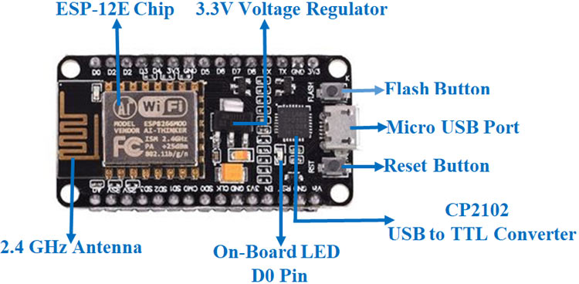

**6.6 NODE MCU**

NodeMCU is an open-source Lua based firmware and development board specially targeted for IoT based Applications. It includes firmware that runs on the ESP8266 Wi-Fi SoC from

Espressif Systems, and hardware which is based on the ESP-12 module.

**6.7 FEATURES AND SPECIFICATIONS**

NodeMCU ESP8266 Specifications &Features

1. Microcontroller: Ten silica 32-bit RISCCPUXtensaLX106
2. Operating Voltage:3.3V
3. Input Voltage:7-12V
4. Digital I/OPins(DIO):16
5. Analog Input Pins(ADC):1
6. UARTs:1
7. SPIs:1
8. I2Cs:1
9. Flash Memory:4MB
10. SRAM:64KB
11. Clock Speed:80MHz
12. USB-TTL based on CP2102 is included onboard, Enabling Plugn Play
13. PCB Antenna
14. Small Sized module to fit smartly inside your IoT projects

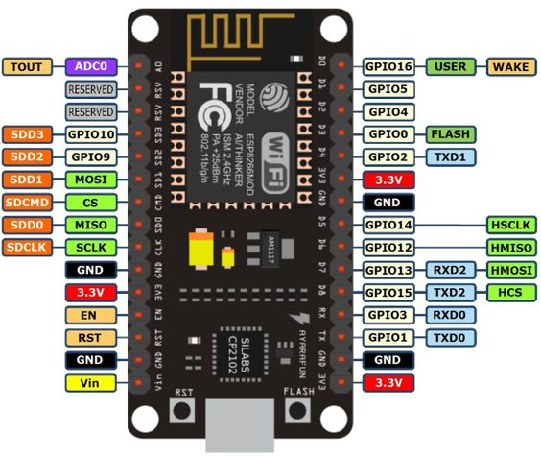

**Figure .8 NodeMCU ESP8266 pinout**

**6.8 PINBOARD CONFIGURATION**

1. Power pins ([3.3](tel:3.3) V).
2. Ground pins (GND).
3. Analog pins (A0).
4. Digital pins (D0 – D8, SD2, SD3, RX, and TX – GPIO XX)
5. Most ESP[8266](tel:8266)NodeMCU boards have one input voltage pin (Vin),
6. three power pins ([3.3](tel:3.3)v),
7. four ground pins (GND),
8. one analog pin (A0), and
9. several digital pins (GPIO XX).

|  |
| --- |
| Pin     Code  Arduino alias |
| A0       A0                                A0 D0       GPIO 16                     16 D1    GPIO 5                       5 D2       GPIO 4                       4 D3       GPIO 0                       0 D4        GPIO 2                       2 D5        GPIO 14                     14 D6        GPIO 12                     12 D7       GPIO 13                     13 D8       GPIO 15                     15 SD2     GPIO 9                9 SD3     GPIO 10                     10 RX      GPIO 3                       3 TX       GPIO 1                       1 |

**6.9 APPLICATIONS**

* Prototyping of IoT Devices
* Low power battery operated applications
* Network projects
* For projects requiring multiple I/O interfaces with WiFi and Bluetooth functionalities.

**CHAPTER 7**

**SENSORS**

**7.1 GENERAL**

A sensor is a device that detects and responds to some type of input from the physical environment. The specific input could be light, heat, motion, moisture, pressure, or any one of a great number of other environmental phenomena. The output is generally a signal that is converted to human-readable display at the sensor location or transmitted electronically over a network for reading or further processing.

**7.2 LIGHT DEPENDENT RESISTOR (LDR)**

An LDR or light dependant resistor I also photo resistor, photocell, photoconductor. It is a one type of resistor whose resistance varies depending on the amount of light failing on its surface. When the light falls on the resistor, then the resistance gets changed. These resistors are often used in many circuits where it is required to sense the presence of light. These resistors have variety of functions and resistance.

1. **WORKING PRINCIPLE OF LDR**

This resistor works on the principle of photoconductivity. It is nothing but, when the light falls on its surface, then the material conductivity reduces and also the electrons in the valence band of the device are excited to the conduction band. These photons in the incident light must have energy greater than the band gap of the semiconductor material. This makes the electrons to jump from the valence band to conduction these devices depend on the light, when light falls on the LDR then the resistance decreases, and increases in the dark.

When a LDR is kept in the dark place, its resistance is high and, when the LDR is kept in the light its resistance will decrease. If a constant “V’ is applied to the LDR, the intensity of the light increased and current increases. The figure below shows the curve between resistance Vs illumination curve for a particular light dependent resistor.

**Types of Light Dependent Resistors**

1. Intrinsic Photo Resistors
2. Extrinsic Photo Resistors
3. **CIRCUIT DIAGRAM**

The circuit diagram of a LDR is shown below.

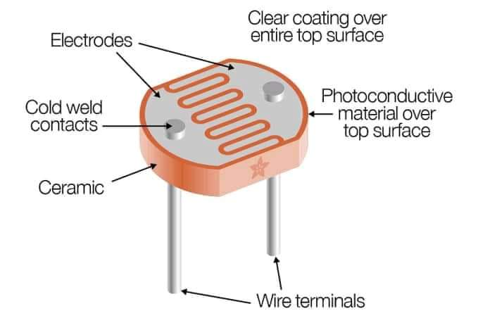

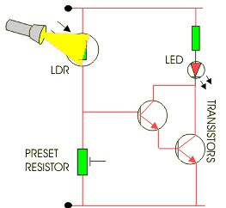

9 (a) 9 (b)

**Figure 9(a). Circuit diagram of LDR & 9(b) LDR**

When the light intensity is low, then the resistance of the LDR is high. This stops the current

Flow to the base terminal of the transistor. So, the LED does not light. However, when the light intensity onto the LDR is high, then the resistance of the LDR is low. So current flows onto the base of the first transistor then to the second transistor. Consequently to the LED lights. Here, a pre set resistor is used to turn up or down to increase or decrease the resistance.

7.3  **INA219 CURRENT SENSOR**

INA219 is a shunt Current Sensor module introduced by the Texas instruments. It is a Zero-Drift, Bidirectional, Power Monitor module that monitors shunt voltage, Bus voltage, current, and power. It has an integrated 12C or SMB us-compatible interface to communicate data to the microcontrollers. Chip has an analog-to-digital converter with a high resolution of 12-bit and 16 programmable addresses for flexible configuration.

It comes with an additional multiplier register that converts the power to watts. It is a small, low-power current sensing module that comes in handy for small embedded projects. The module consists of an INA219 chip, I2CBus, and a Current Sensing Resistor.

1. **CURRENT SENSING RESISTOR**

The module has as hunt resistor to measure current, voltage, and power by measuring the

Voltage drop across it. It can be altered per requirement.

1. **SPECIFICATIONS AND FEATURES**
2. Operational Voltage: 3–5.5 Volts
3. Operating Temperature: -400C–1250 C
4. Maximum Voltage: 6 Volts
5. Bus Voltage Range: 0–26 Volts
6. Current sensing Range: ±3.2A with ±0.8mA resolution
7. 0.1 ohm 1% 2W current sense resistor

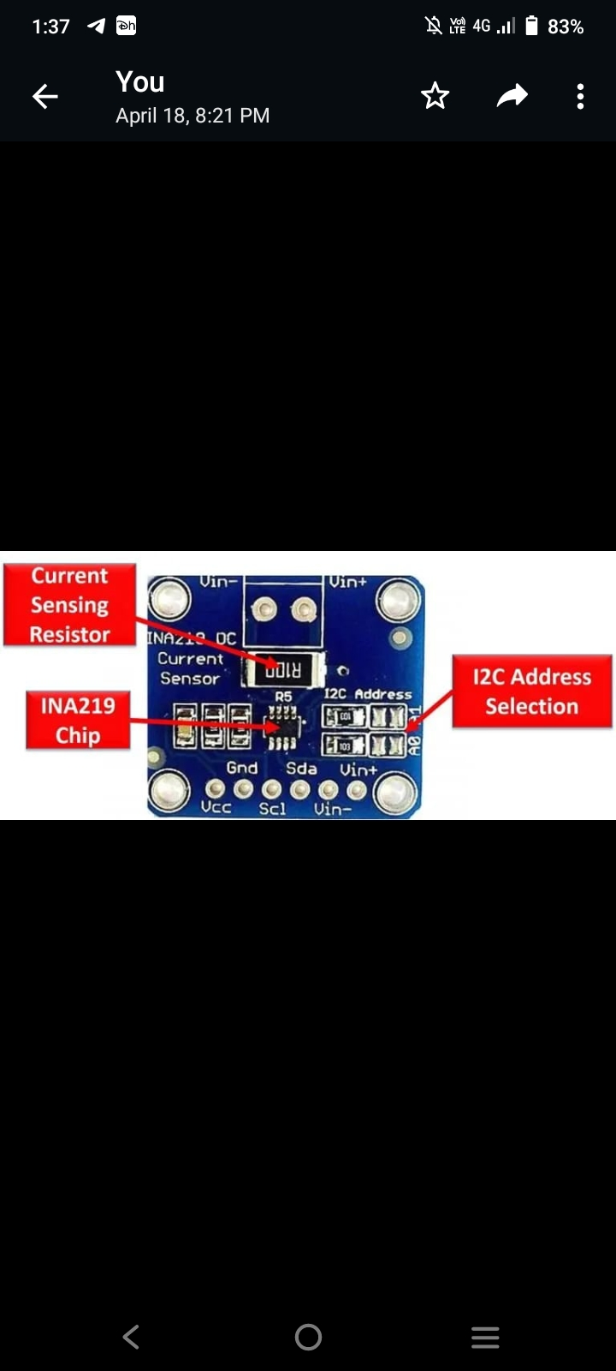

**Figure 10. components of INA219 current sensor**

**Some of the extra features include:**

* It has in built calibration registers to reduce uncertainty in the power, voltage, and current values.
* It contains 16 programmable addresses and filtering options.
* The sensor is available in 2 grades i.e. INA219A and INA219B.
* The Accuracy is upto 0.5% in INA219B over the temperature.
* The sensor has two package types i.e. SOT23-8 and SOIC-8.

1. **INA219 PINOUT**

The following diagram shows the pin out of the INA219 Current Sensor Module:

Let us discuss the pin out of the INA219 Current Sensor Module. The pin configuration detail in tabular is mentioned below:

In these pins the vcc and gnd pins are used for the power supply. SCL and SDA for the i2c communication and Vin+ and Vin- pins for measuring the voltage. On the board you can see A0 and A1 these are used for the I2C Address selection.

The R100 is the Current Sense Resistor and the small chip in the middle is the INA219 chip. The INA219 Current Sensor is most commonly used:

1. Power Profier.
2. Digital Multimeter

**Pin Description of INA219**

|  |
| --- |
| **Pin No. Pin Description Pin Name** |
| 1. Sensed Input line – VIN- 2. Sensed Input line + VIN+ 3. Input voltage VCC 4. Connected to ground GND 5. Serial clock line that carries the clock signal SCL 6. Serial data line that contains the data SDA |

1. **REGISTER DESCRIPTION**

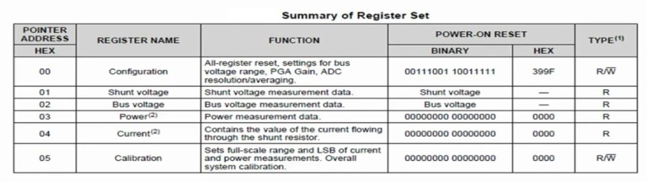

There are six registers, two configurable registers, and four read-only registers with the configuration register we can set the mode of operation voltage measurement range ADC resolution and so on.

The calibration register is used current and power calculations which we can read from the current and power registers.

Current and power flowing to the load can be calculated using these formulas directly from the values read from the shunt and bus voltages registers.

Current (A) = (Shunt Voltage Reg * 10 μV ) / shunt Resistor

Power (W) = current * Bus voltage Reg * 4 mV

However you can also obtain current and power values directly from the registers after setting the calibration register using this formula:

Current value = 0.04096 (Current LSB * Rshunt)

current lsb is the desired resolution of the current register value and should be selected a value between maximum expected current divided by 2 to the 15th to maximum expected current divided by 2 to the 12th and of course the maximum expected current should be equal to or smaller than the current measurement range which was mentioned above.

After setting the calibration register you can read the register value from the current and power register and obtain an actual value in amperes and watts using these formulas:

current (A) = Current Reg * Current LSB

Power (W) = Power Reg * 20 * current LSB

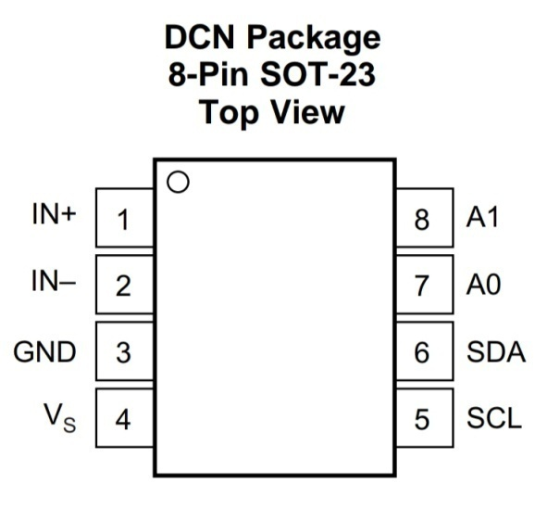

**Figure 11. INA219 Pinout**

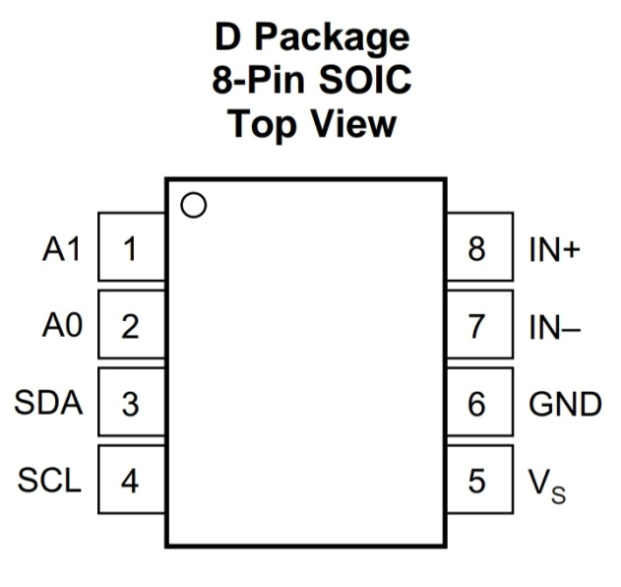

The following picture shows the pin out diagram of current sensor module and the pins which are exponses through header:

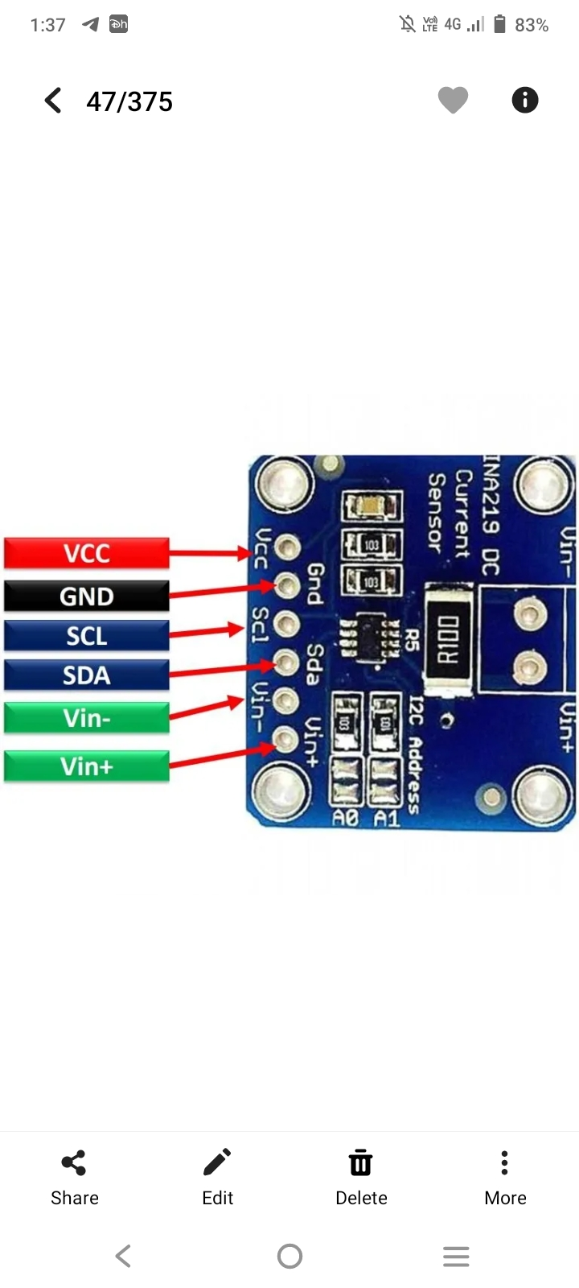

1. **INA219 CHIP**

The integrated Circuit is responsible for all the signal and data processing I2C Interface:

The I2C bus consists of SDA and SCL and serves the purpose of communicating data between the module and the microcontroller.

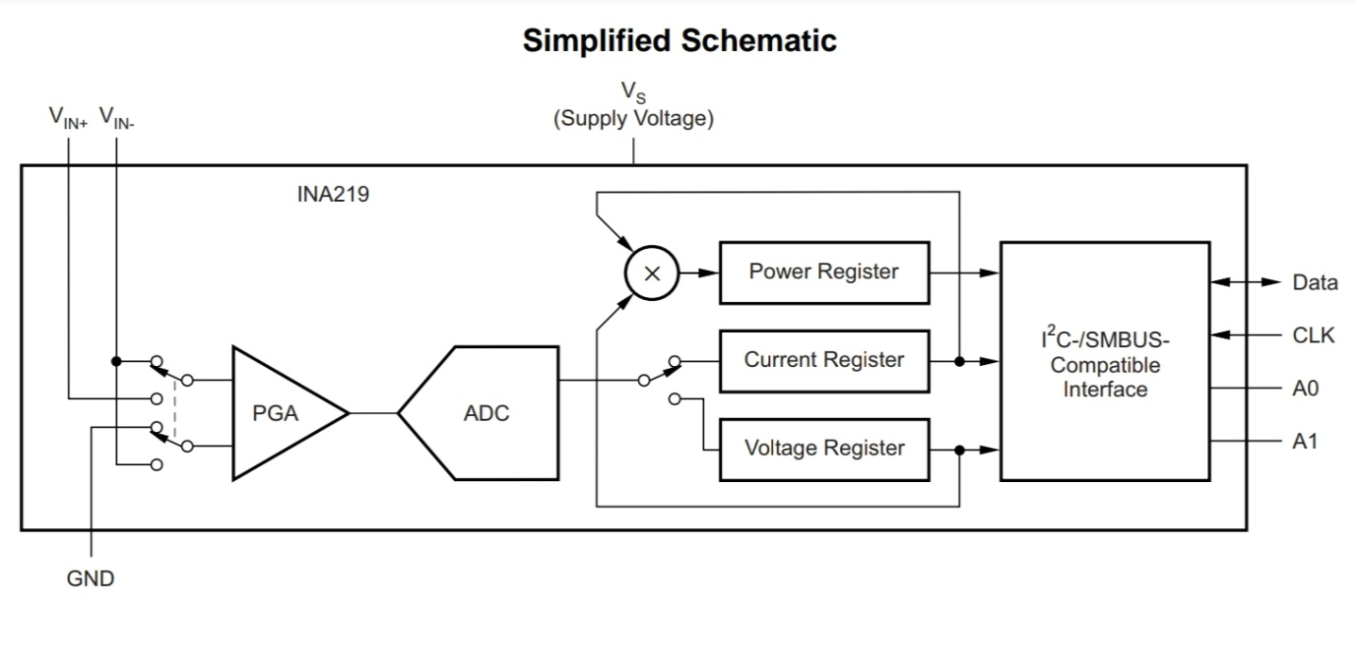

**Figure 12. INA219 Schematic diagram**

1. **APPLICATIONS**
2. Servers
3. Telecom equipment
4. Notebook computers
5. Power management
6. Battery chargers
7. Welding equipment
8. Power supplies
9. Test equipment

**7.5 DS18B20 TEMPERATURE SENSOR**

The DS18B20 is one type of temperature sensor and it supplies 9-bit to 12-bit readings of temperature. These values show the temperature of a particular device. The communication of this sensor can be done through a one-wire bus protocol which uses one data line to communicate with an inner microprocessor.

Additionally, this sensor gets the power supply directly from the data line so that the need for an external power supply can be eliminated. The applications of the DS18B20 temperature sensor include industrial systems, consumer products, systems which are sensitive thermally, thermostatic controls, and thermometers.

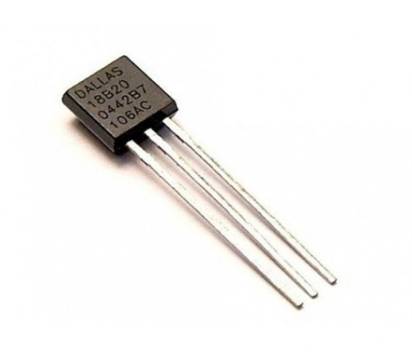

**Figure 13. DS18b20 temperature sensor**

1. **PIN CONFIGURAITION**

|  |
| --- |
| **No:** **Pin Name** **Description**  Value which can be read using 1-wire method |
| 1 Ground Connect to the ground of the circuit  2 Vcc gives power to the sensor of range 3.3V-5V  3 Data This pin gives output the temperature |

1. **DS18B20 SENSOR SPECIFICATIONS**
2. Programmable Digital Temperature Sensor
3. Communicates using 1-Wire method
4. Operating voltage: 3V to 5V
5. Temperature Range: -55°C to +[125](tel:125)°C
6. Accuracy: ±[0.5](tel:0.5)°C
7. Output Resolution: 9-bit to 12-bit (programmable)
8. Unique 64-bit address enables multiplexing
9. Conversion time: [750](tel:750)ms at 12-bit
10. Programmable alarm options
11. Available as To-92, SOP and even as a waterproof sensor
12. **DS18B20 EQUIVALENT SENSORS**

DS18S20

1. **WORKING**

The sensor works with the method of 1-Wire communication. It requires only the data pin connected to the microcontroller with a pull up resistor and the other two pins are used for power as shown below.

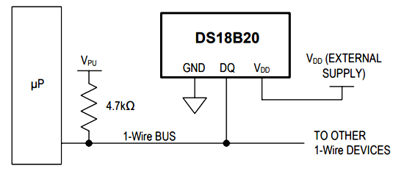

**Figure 14. Temperature sensor and its circuit diagram**

1. **DS18B20-MICROCONTROLLER CIRCUIT DIAGRAM**

The pull-up resistor is used to keep the line in high state when the bus is not in use. The temperature value measured by the sensor will be stored in a 2-byte register inside the sensor. This data can be read by the using the 1- wire method by sending in a sequence of data. There are two types of commands that are to be sent to read the values, one is a ROM command and the other is function command.

The address value of each ROM memory along with the sequence is given in the datasheet below. You have to read through it to understand how to communicate with the sensor.

1. **APPLICATIONS**
2. Measuring temperature at hard environments
3. Liquid temperature measurement
4. Applications where temperature has to be measured at multiple points

**CHAPTER 8**

**BATTERY AND BATTERY CHARGER MODULE**

**8.1 GENERAL**

In electricity and electrochemistry, any of a class of devices that convert chemical energy directly into electrical energy is called as a battery. Although the term battery, in strict usage, designates an assembly of two or more galvanic cells capable of such energy conversion, it is commonly applied to a single cell of this kind.

Every battery (or cell) has a cathode, or positive plate, and an anode, or negative plate. These electrodes must be separated by and are often immersed in an electrolyte that permits the passage of ions between the electrodes. The electrode materials and the electrolyte are chosen and arranged so that sufficient electromotive force (measured in volts) and electric current (measured in amperes) can be developed between the terminals of a battery to operate lights, machines, or other devices.

Since an electrode contains only a limited number of units of chemical energy convertible to electrical energy, it follows that a battery of a given size has only a certain capacity to operate devices and will eventually become exhausted. The active parts of a battery are usually encased in a box with a cover system (or jacket) that keeps air outside and the electrolyte solvent inside and that provides a structure for the assembly.

Commercially available batteries are designed and built with market factors in mind. The quality of materials and the complexity of electrode and container design are reflected in the market price sought for any specific product. As new materials are discovered or the properties of traditional ones improved, however, the typical performance of even older battery systems sometimes increases by large percentages.

Batteries are divided into two general groups:

1. Primary batteries.
2. Secondary or storage batteries.

**8.2 BATTERY CHARGER MODULE**

This module is made for charging rechargeable lithium batteries using the constant-current/constant-voltage (CC/CV) charging method.

In addition to safely charging a lithium battery the module also provides necessary protection required by lithium batteries. In this project battery charger module is used.

Almost all the electronic devices run with batteries.

And these batteries can get discharged. Therefore, chargers are used to charge them by putting energy into them.

**CHAPTER 9**

**HARDWARE SETUP**

Figure 3 Illustrates the Experimental setup of a solar power monitoring system based on IoT.

This setup includes a Node MCU microcontroller, Sensors such as a INA219 Current sensor module, a Battery Charger module, a Battery, an LDR, a DS18B20adigital temperature sensor, and a solar panel that measures parameters.

The Node MCU is responsible for live streaming current, voltage, power, light intensity, and temperature, as well as sending sensor data to the server via the ESP8266 Wi-Fi module.

The sensors are connected to the microcontroller (Node MCU), which is powered by an external power supply.

The values of the sensors are read by NodeMCU, and the data is sent to the cloud server by this microcontroller.

Extra power will be stored in the battery for later use via the Battery Charger Module.

As a result, the user can monitor the above- mentioned parameter**.**

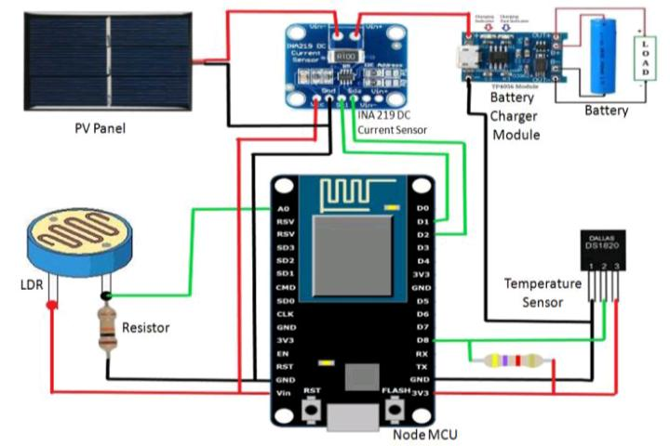

**Figure 15. Experimental setup**

The practical circuit setup of the proposed system is shown in Figure 4.

**Figure 16. Practical experimental circuit diagram of proposed system**

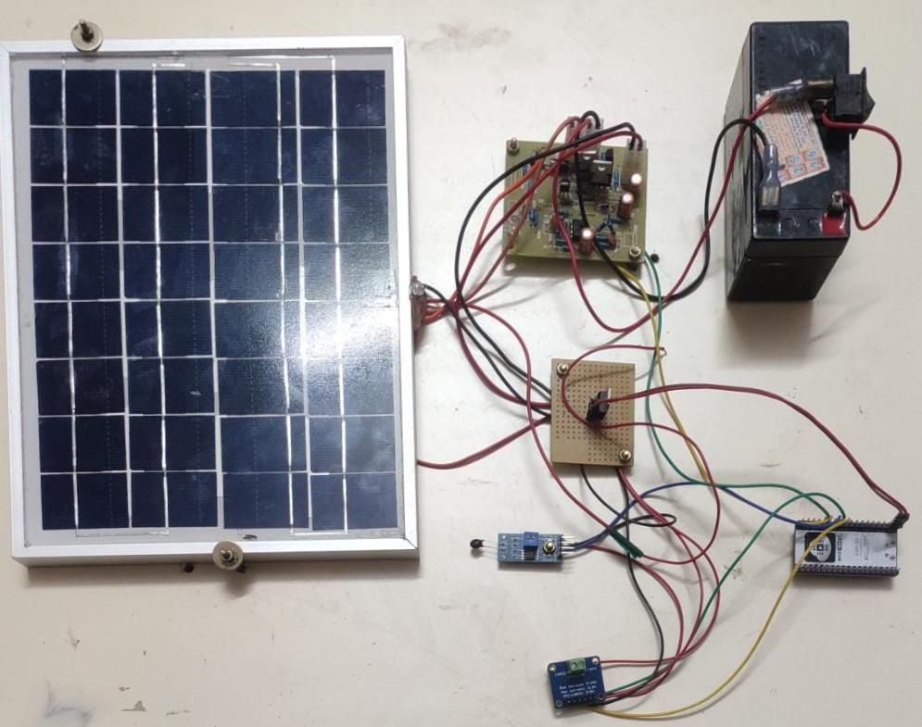

**CHAPTER 10**

**RESULTS AND DISCUSSION**

This system’s readings are taken at a specific field for a single day at a specific time interval.

Readings are taken in the morning, afternoon, and night, and are graphically presented below.

**(A) At Morning**

Figures 17(a)-(e) demonstrates the recorded data of Bus Voltage, Current, Power, Light Intensity, and Temperature at a specific time of the day in the morning. Fig. 17(a) depicts the System Voltage Readings as measured by the INA 219 Current Sensor Module between 11.04 am and 11.14 am on a specific day. The maximum voltage generated by solar photovoltaic panels is 7.7 volts, while the minimum voltage is 7.0 volts.

Figure 17(b) depicts the value of Current across the load, which is Shunt Resistance, as recorded by the INA 219 Current Sensor Module in the morning between 11.04 am and 11.14 am on a specific day. The maximum sensed current in a given time interval is approximately 1 mA, while the minimum sensed current is approximately 0.12 mA.

Fig. 17(c) illustrates the Power Curve, which is the product of voltage and current sensed by the INA 219 Current Sensor Module and is recorded at a specific time in the morning between 11.04 am and 11.14 am on a specific day. In this case, the maximum recorded power is 18 mW, while the minimum power is around 13.2 mW.

Figure 17(d) shows the recorded value of light intensity on solar PV panels by LDR sensor between 11.04 am and 11.14 am on a particular day. At that time, the maximum light intensity is nearly 0.3 Candela (cd), while the minimum value is nearly 0.27 cd. We used the DS18B20a sensor to measure the temperature on the surface of the solar panel, which was recorded in a specific time interval in the morning on a specific day.

Fig. 17(e) depicts the temperature variation between on a particular day. The temperature is varied between 70.5°C and 68.6°C within that specific instance.

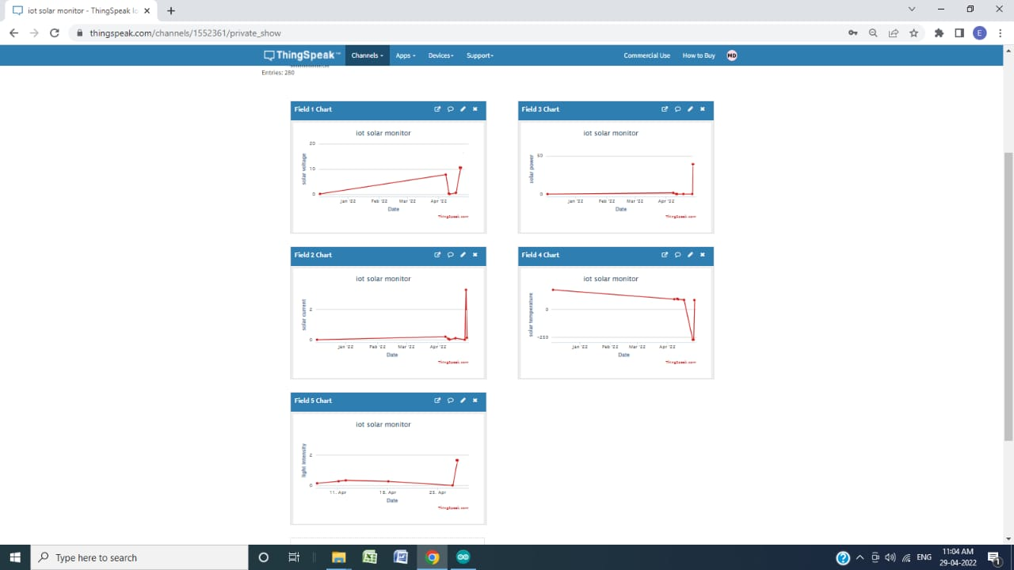Figure 17. Recorded data in the morning (a) Bus Voltage Vs Date/Time graph; (b) Current Vs Date/Time; (c) Power Vs Date/Time; (d) Light Intensity Vs Date/Time; (e) Temperature Vs Date/Time

**(B) At Afternoon**

Figures 18(a)-(e) demonstrates the recorded data of Bus Voltage, Current, Power, Light Intensity, and Temperature at a specific time of the day in the afternoon. Fig. 18(a) represents the voltage reading of the developed system between 2.15 and 2.25 pm on a specific day. Since the maximum amount of light falls on the solar PV panel during that time interval, we have a maximum generated voltage of nearly 19.8V, which is higher than the value in the morning.

Figure 18(b) represents the value of the current reading in the afternoon, which was recorded between 2.15 and 2.25 pm pm on a specific day. During that time, the maximum current is approximately 3.3 mA, and the minimum current is approximately 0.01 mA.

The power curves shown in Fig. 18(c) represent data collected by the INA 219 Current Sensor Module in the afternoon. Due to the extreme light intensity between 2.15 and 2.25 pm pm on a specific day, the maximum value obtained during that period was 29.4 mW, which was greater than the value obtained in the morning for that specific day.

The graph in Fig. 18(d) describes the intensity of light during a time interval between 2.15 and 2.25 pm in the afternoon on a specific day. We can see from the graph that the Light Intensity is always at its maximum value, which is 3.3 cd.

Fig. 18(e) depicts the temperature variation on the surface of the solar panel between 2.15 and 2.25 pm on a specific day. The maximum temperature reached 89.2°C in this graph, while the minimum temperature reached 85°C.

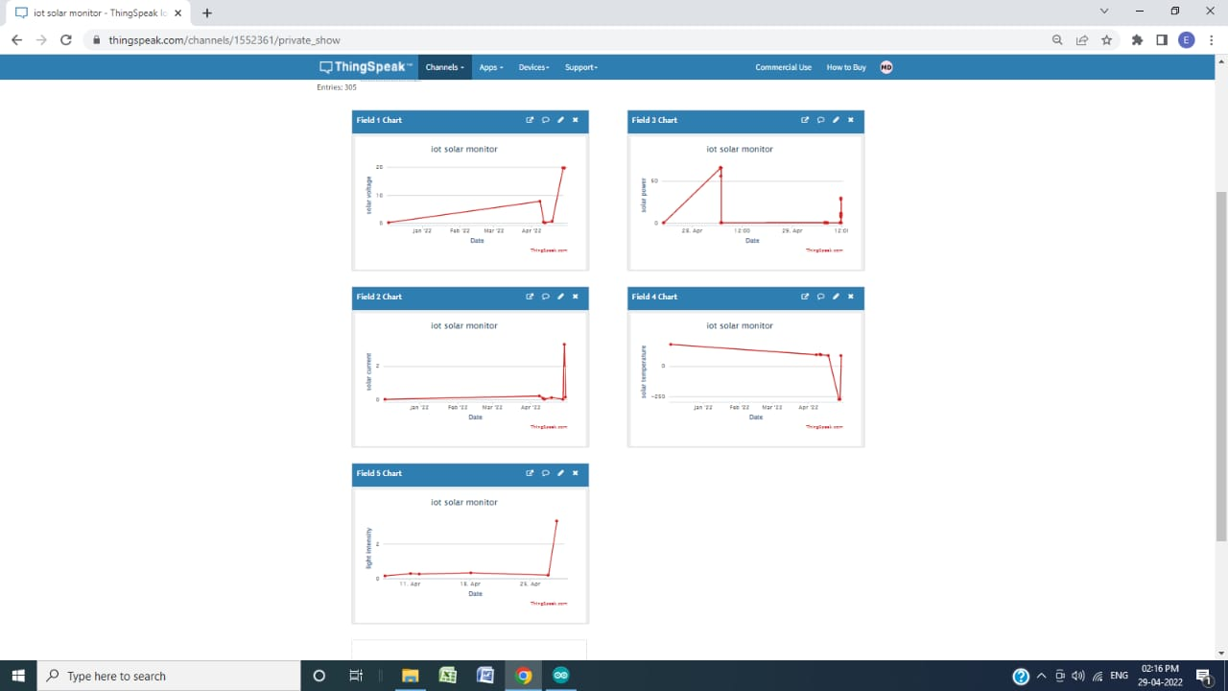Figure 18 Recorded data in the afternoon (a) Bus Voltage Vs Date/Time graph; (b) Current Vs Date/Time; (c) Power Vs Date/Time; (d) Light Intensity Vs Date/Time; (e) Temperature Vs Date/Time

**(C) At Night**

Figures 19(a)-(e) demonstrate the recorded data of Bus Voltage, Current, Power, Light Intensity, and Temperature at a specific time of the day in the night.

Fig. 19(a) shows the voltage generated by Solar PV panels on a specific day at night in between 07.40 pm and 07.50 pm. Due to low light intensity at night, the maximum value of generated voltage is nearly 0.78V during this period, while the minimum value of generated voltage is 0.17V.

Figure 19(b) depicts the generated current across the load at night between 07.40 pm and 07.50 pm on a specific day. In this case, the maximum generated current sensed by the INA 219 Current sensor is approximately 1.28 mA, while the minimum current is approximately 0.6 mA.

The graph of Fig. 19(c) illustrates the value of generated power at night between 07.40 pm and 07.50 pm on a specific day. We can see that the maximum power is about 12mW, which is very low as compared to the afternoon and morning because the light intensity on the solar PV panel is lowest at night. While the lowest value of generated power is approximately 0.1007 mW.

Figure 19(d) depicts the value of light intensity falling on solar PV panels from 07.40 pm and 07.50 pm on a specific day. During this time period, the maximum light intensity was 3.3 cd, while the minimum light intensity was 0.26 cd. The variation in light intensity at night is less than it is in the morning and afternoon.

Fig. 19(e) represents the value of temperature on the surface of the solar panel at night on a specific day between 07.40 pm and 07.50 pm. It is seen that the temperature fluctuates between -27°C and 20°C during that time period.

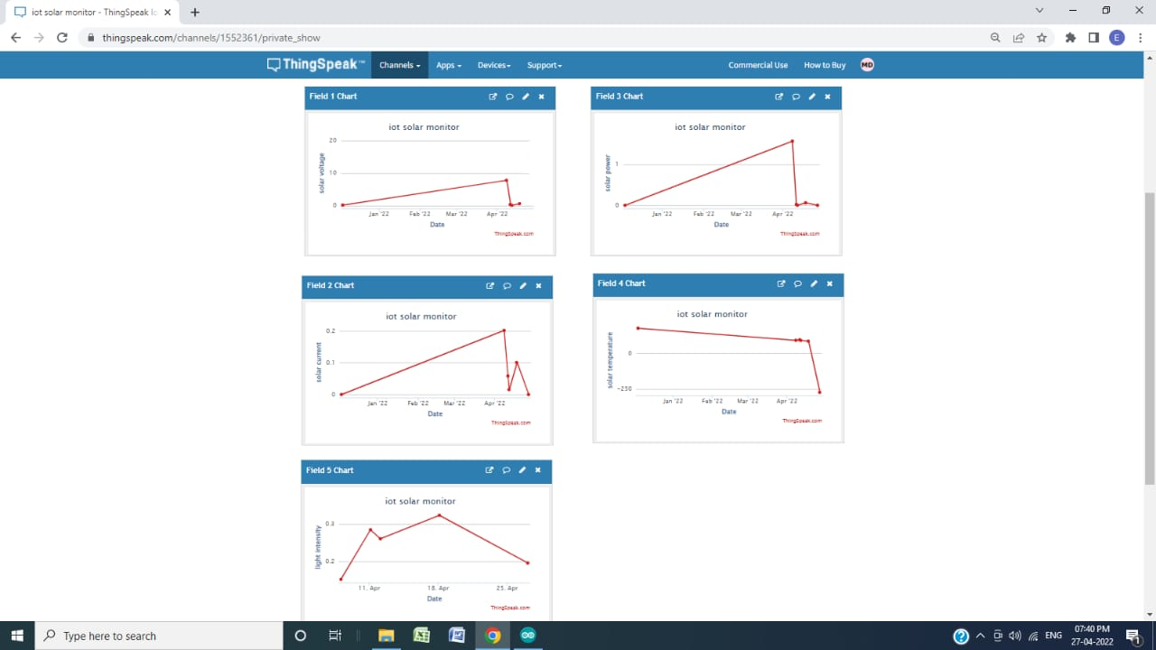Figure 19 Recorded data in the night (a) Bus Voltage Vs Date/Time graph; (b) Current Vs Date/Time; (c) Power Vs Date/Time; (d) Light Intensity Vs Date/Time; (e) Temperature Vs Date/Time

**CHAPTER 11**

**CONCLUSION**

In this project, an IoT-based real-time solar power monitoring system was successfully developed, which included a microcontroller (Node MCU), a PV panel, sensors (INA219 current module, Digital temperature sensor, and LDR), a Battery charger module, and a Battery.

The system could collect instantaneous data from remote locations or far from the control center and monitor in real-time of the produced power and environmental conditions of PV panels such as voltage, current, Temperature, and light intensity using a GUI via connected devices. The use of IoT enables continuous recording and monitoring of real-time data that can be used for data analysis to predict and estimate future power generation possibilities income output, and so on.

As a result, the use of this IoT-based system will make recorded data analysis easier and more efficient, reduce intervention and supervision time, simplify network management, and eliminate the need for regular PV system maintenance.

Since the range of the sun's radiation is not fixed and can vary depending on location, time.

So, we can control the PV panel by making an arrangement of Solar Power Tracking System for efficient use of maximum possible amount of solar radiation to get maximum output.

This Solar Power Monitoring system will also provide an advantage in the event of a fault occurring in any part of the system**.**

**REFERENCES**

[1] Bipin Krishna, Kaustav Sinha (2013), “Tracking of Sun for Solar Panels and Real-Time Monitoring Using LabVIEW”, Journal of Automation and Control Engineering Vol. 1, pp.1-4.

[2] SohamAdhya, DipakSaha, Abhijit Das, Joydip Jana, HiranmaySaha (2016), "An IoT Based Smart Solar Photovoltaic Remote Monitoring and Control unit", IEEE International Conference on Control, Instrumentation, Energy & Communication (CIEC), pp.432-436.

[3] Renata I. S. Pereira, Ivonne M. Dupont, Paulo C. M. Carvalho, Sandro C. S. Juca (2017), " IoT Embedded Linux System based on Raspberry Pi applied to Real-Time Cloud Monitoring of a decentralized Photovoltaic plant", International Journal of measurement Elsevier, Vol. 2, pp. 1-18.

[4] Bruno Ando, Salvatore Baglio, Antonio Pistorio (2015), “Sentinella: Smart monitoring of photovoltaic system at panel level”, IEEE Transaction on Instrumentation and measurement, Vol.64, pp.2188-2199.

[5] Amit Kumar Rohit, Amit Tomar, Anurag Kumar, SarojRangnekar(2017), “Virtual lab-based realtime data acquisition, measurement and monitoring platform for solar photovoltaic module", International Journal of Resource-Efficient Technologies, pp.1-6.

[6] N.A. Othman, N.S. Damanhuri, I.R. Ibrahim, R. Radzali, M.N. Mohd (2010), “Automated Monitoring System for Small Scale Dual-Tariff Solar PV plant in UiTMPulau Pinang", Proceedings of the World Congress on Engineering(WCE) U.K, Vol.2, pp.1-3.

[7] P. Papageorgas, D. Piromalis, K. Antonakoglou, G. Vokas, D. Tseles and K. G. Arvanitis(2013), "Smart Solar Panels: In-situ monitoring of photovoltaic panels based on wired and wireless sensor networks", International Conference on Advancements in Renewable Energy and Clean Environment, Vol.36, pp. 535-545.

[8] Hugo T.C. Pedro, Edwin Lim, Carlos F.M. Coimbra(2018), “A database infrastructure to implement real-time solar and wind power generation intra-hour forecasts”, International Journal of Renewable energy Elsevier, Vol.123, pp.513-525.

[9] R. Nagalakshmi, B. Kishore Babu, D. Prashanth (2014), “Design and Development of a Remote Monitoring and Maintenance of Solar Plant Supervisory System", International Journal Of Engineering And Computer Science, Vol.3, pp.9382-9385.

[10] AissaChouder, Santiago Silvestre, Bilal Taghezouit, EnginKaratepe(2013), “Monitoring, modeling and simulation of PV systems using LabVIEW”, International Journal of Solar energy Elsevier, Vol.1, pp.337-349.

[11] Haider-e-Karar, Aziz AltafKhuwaja, Abdul Sattar (2015), "Solar Power Remote Monitoring and Controlling Using Arduino, Labview and Web browser", IEEE International Conference on Power Generation System and Renewable Energy Technologies, pp.1-4.

[12] KangkanaHazarikaa, Pradyumna Kumar Choudhury(2017), “Automatic monitoring of solar photovoltaic (SPV) module", Science direct proceedings Vol. 4, pp.12606-12609.

[13] Rajalingam S., Malathi V (2016), “HEM algorithm-based smart controller for home power management system”, International Journal of Energy and Buildings ELSEVIER, Vol.131, pp. 184-192.

# APPENDIX